## SH3 - Washing Your Hands Sequencing Activity

**Back**

**of fingers**

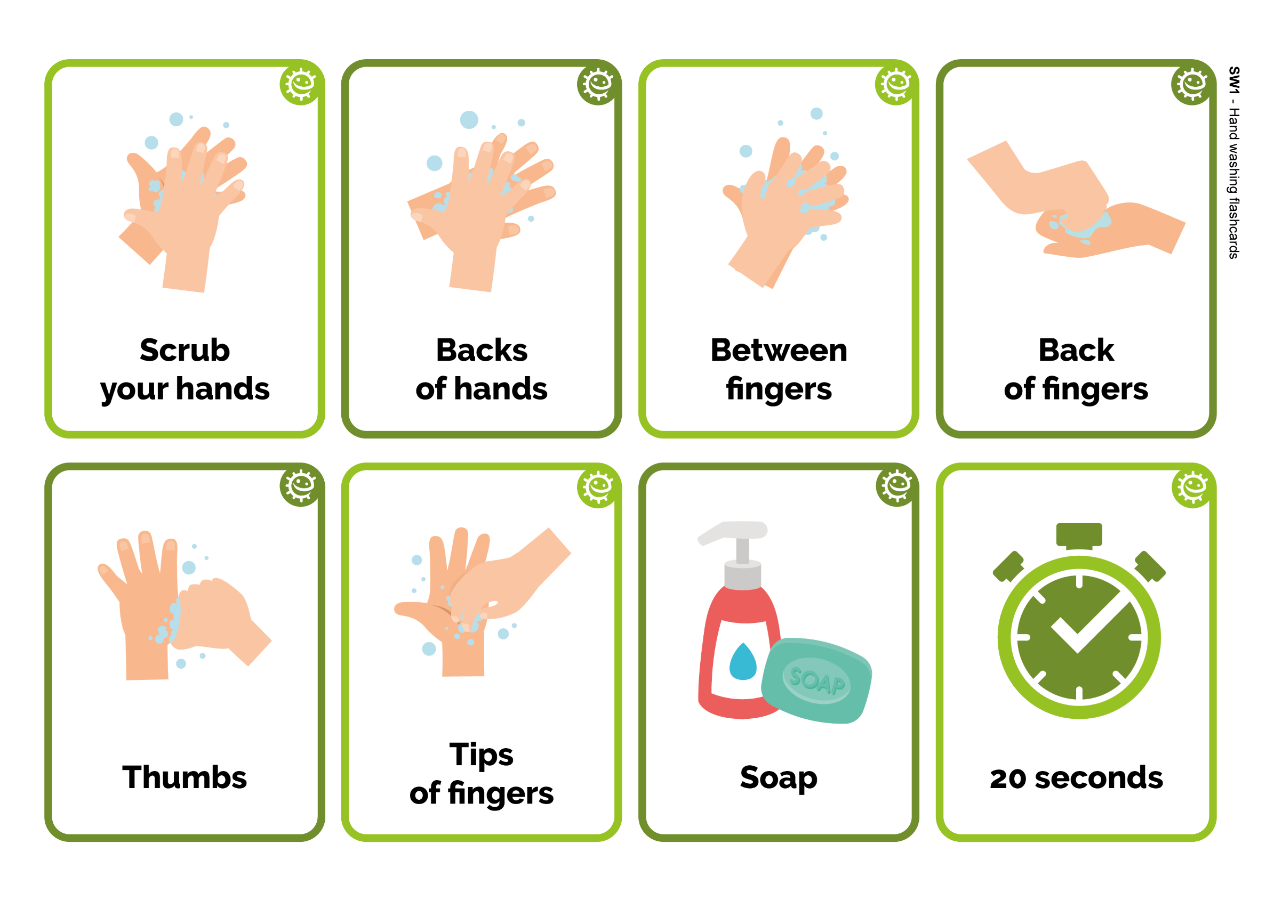

Back

of fingers



20 seconds



Between fingers



Soap

**Backs**

**of hands**



Backs

of hands



Tips of fingers

Scrub

your hands

Scrub

your hands



Thumbs

